**Data Pruning in SAP HANA**

**Applies to:**

SAP HANA. Will work on SAP HANA SP11.

**Summary:**

This article describes how to use the new Data Pruning concept introduced in SAP HANA SP11.

**Author:**

Rajeev Jagatap is a SAP BI, HANA Senior Consultant currently working with Tech Mahindra Ltd, Spain. He has got good experience and worked on various BW/BI/Hana Implementations/Support projects.

Contents

Introduction / Requirement: 3

What is Data Prune? 3

Pros and Cons 3

Pros: 3

Cons: 3

Pre requisites: 3

Scenario: 3

How to Achieve: 4

Before Vs after Data Prune 6

## Introduction / Requirement:

This article describes how to use the Data Pruning Concept in SAP HANA.

## What is Data Prune?

Data Prune is the concept where we direct the tool refer to correct node of the calculation view in run time (dynamically) during the query execution time by the end user.

## Pros and Cons

### Pros:

* Easy maintenance with the Prune Configuration table.
* Cost of execution time reduces in case of huge data volumes.

### Cons:

* Manually intervention is required when new filter condition is to be added.

## Pre requisites:

For Pruning data, we need Union node in Calculation View.

## Scenario:

If a query is being executed on top of this CV, where we have ‘N’ number of nodes, depending on the filter ‘AO09’ during execution time, only that node needs to be routed.

Union

Union

## How to Achieve:

1. Create a Pruning Configuration Table as below.

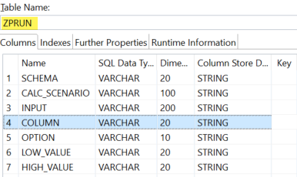

1. Insert entries into the table as below.
   1. CALC_SCENARIO: Name of the CV
   2. Input: Node names
   3. Option: Condition (=, <, >..)
   4. LOW_Value: Initial Value (Ex: Range from AO01 to AO99)
   5. HIGH_Value: Highest Values (Ex: Range from AO01 to AO99)

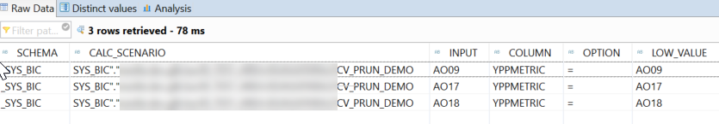

1. Create a calculation view as below.

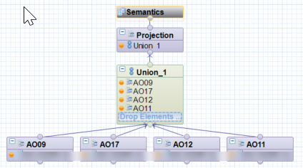

1. Go to Advanced Parameters of the Calculation View and update the above prune configuration table.

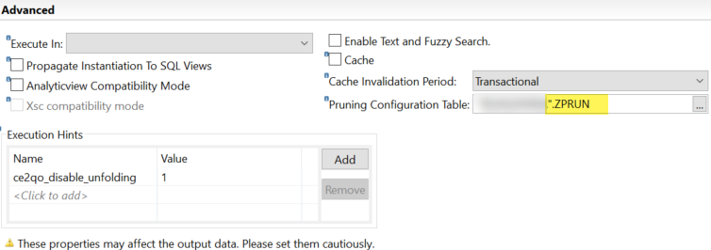

1. Execute the query on that view with a filter condition, which meets the Prune Configuration Table.

SELECT * FROM "_SYS_BIC".".._TEST_AREA. /ZCV_PRUN_DEMO"

Where (***METRIC='AO09')

1. Now go to execution plan and there you can visualize how the Prune configuration table reduces the cost of execution of calculation view.

## Before Vs after Data Prune

The execution plan shows the optimized path after data pruning.

